**TECH 1015- EVALUATION AND REFLECTION**

First, I would like to say this was a very difficult thing that I have never done before, so I am proud and on what I was able to do and know and willing to learn more from here.

As you can tell everybody liked my website as I think they know it was my first time doing it! It helped me feel much more confident with myself as I know it was good just based off people saying they liked 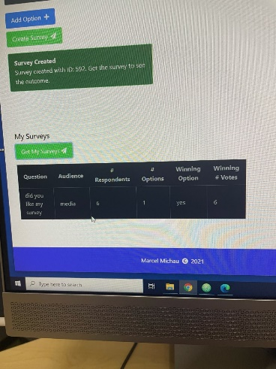it. The main compliments from people were saying that it seemed like I tried the hardest things to (audio, images) and overall succeeding and they looked professional, this then made the website look way more professional overall. The other compliments I was getting were the background was changed to a good color (blue) that kind of balanced the movie I was representing and promoting with the website. I was happy with these responses as it showed my hard work has paid off and people understood the hard work that I had put into the project even if it does not look like much to an outsider. That was kind of what I was left with the compliments of this website and left me feeling happy and wanting to learn and do more in the future!

Cannot have compliments without some constructive criticism, for example people said there was not enough detail on the website although it did cover everything that needed to be on the website. This is shown on the home page as although it does have everything that is supposed to be on their it looks like it is shoved on there and not put there in an appropriate fashion. On the cast page this is kind of the same thing and there is not a description for Zoey Deschanel as I could not fit it on the page because of the audio file on there. This is something I will learn in the future to help make my pages feel more filler and easier to look at.

Overall, with the help of the survey and how well I think I did, I know I can be proud of this piece of work but know there is a long way to go before I am some sort of coding master!

**CONTEXT**

youtube. (2005). *youtube.* Available: https://www.youtube.com/. Last accessed 2nd thursday 2021.

searchlightpictures. (2009). *500 days of summer trailer.* Available: https://www.youtube.com/watch?v=PsD0NpFSADM. Last accessed 2nd thursday 2021

dmu. (2009). *dmu blackboard.* Available: https://vle.dmu.ac.uk/bbcswebdav/pid-5332820-dt-content-rid-10967463_1/courses/TECH1015_2122_520/TECH1015_22_Module%20Handbook.pdf. Last accessed 2nd thursday 2021

Castro, E. & Hyslop, B. (2015). HTML and CSS 8th Ed. Peachpit Press. Kimberlin Library shelf mark: 005.72/HTM CAS Resource List Link: https://rl.talis.com/3/dmu/items/01A2C757-DC2E-47E1-DDDEDD60E6193355.htm